COMPILER DESIGN LABORATORY
LEXICAL ANALYZER PROGRAMS (11–20)
EXPERIMENT RECORD
Department: Information Technology
Subject: Compiler Design
Subject Code: CSA1410
Submitted by: Keerthana.G
Register Number: 192521446

Exp. No. 11
Implement Lexical Analyzer using FLEX (Fast Lexical Analyzer). The program should separate the tokens in the given C program and display with appropriate caption.

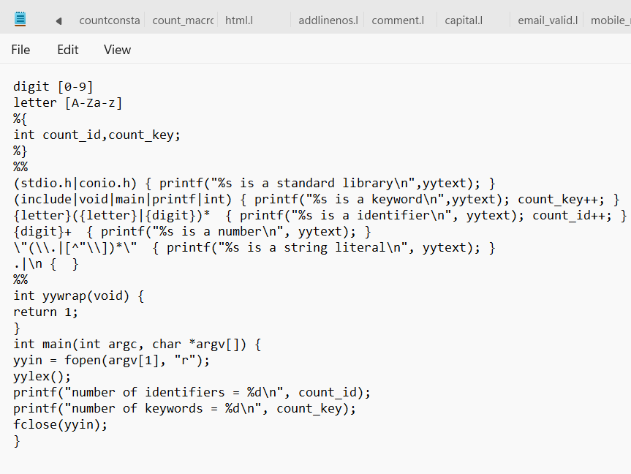
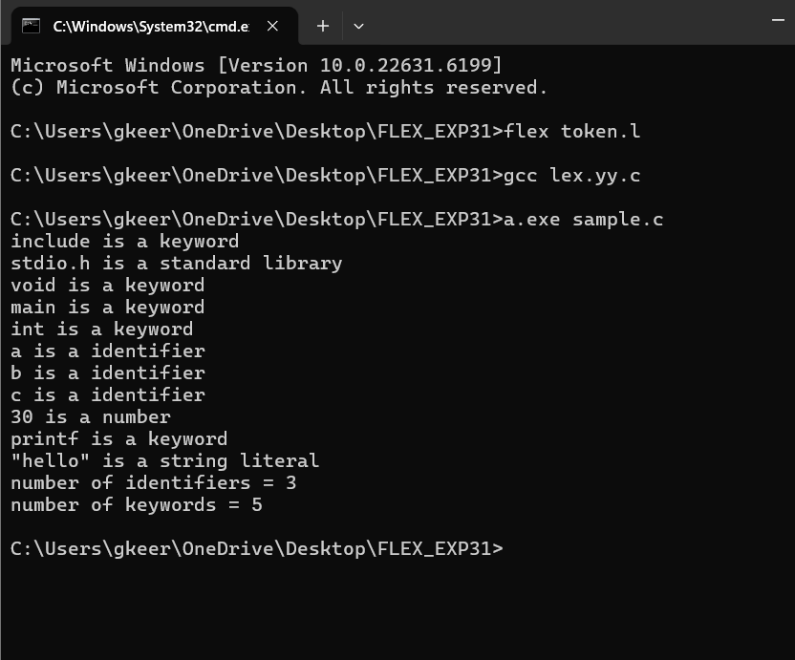

Exp. No. 12
Write a LEX program to count the number of vowels in the given sentence.

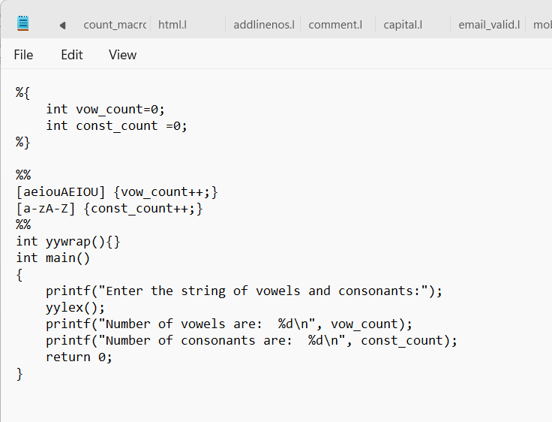
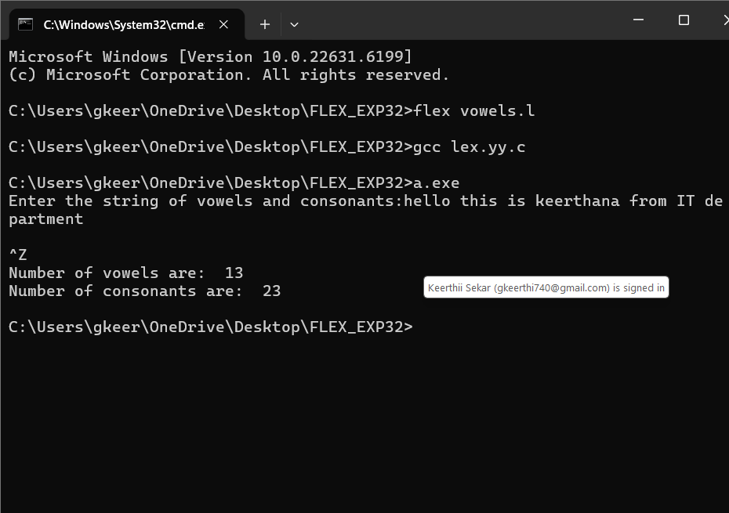

Exp. No. 13
Write a LEX program to count the number of vowels in the given sentence.

Exp. No. 14
Write a LEX program to separate the keywords and identifiers.

Exp. No. 15
Write a LEX program to recognise numbers and words in a statement.

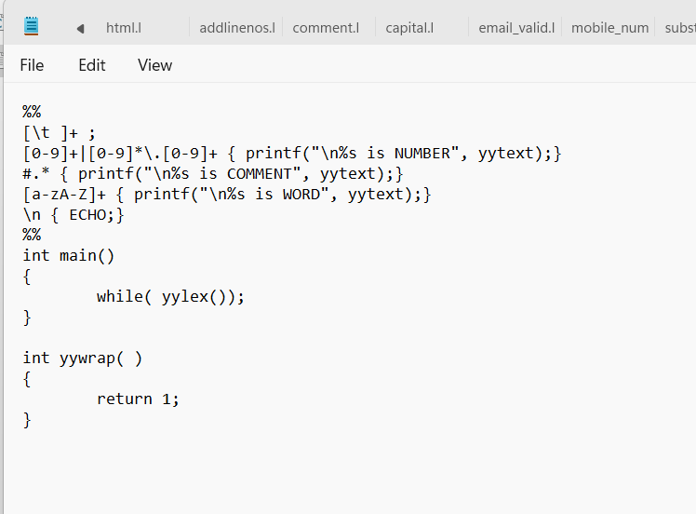
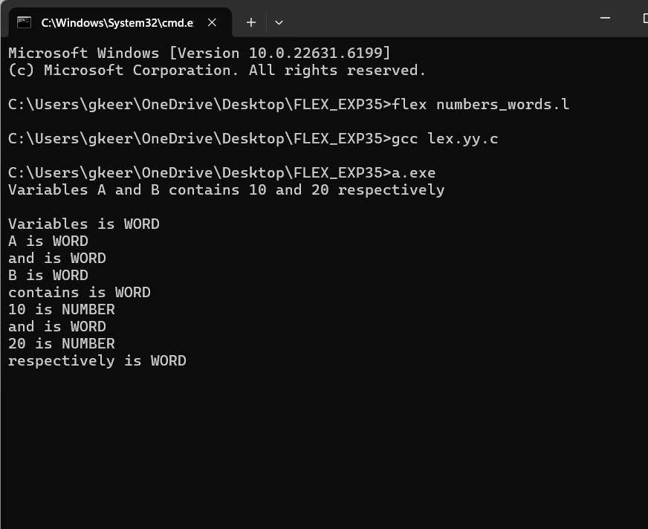

Exp. No. 16
Write a LEX program to identify and count positive and negative numbers.

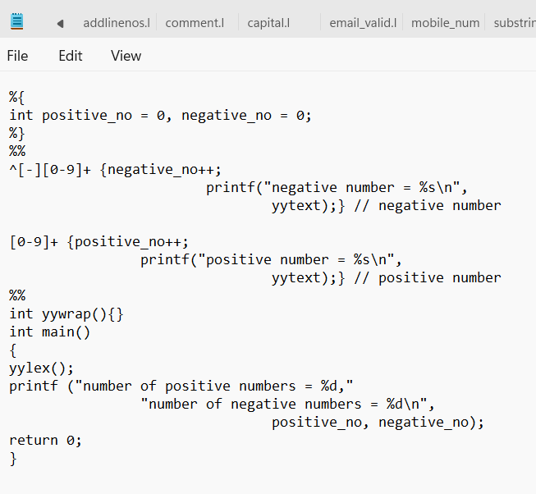
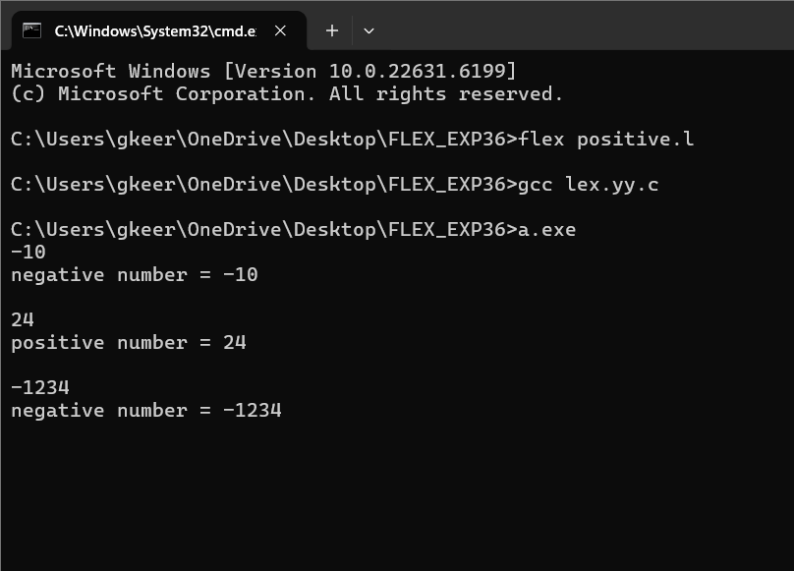

Exp. No. 17
Write a LEX program to validate the URL.

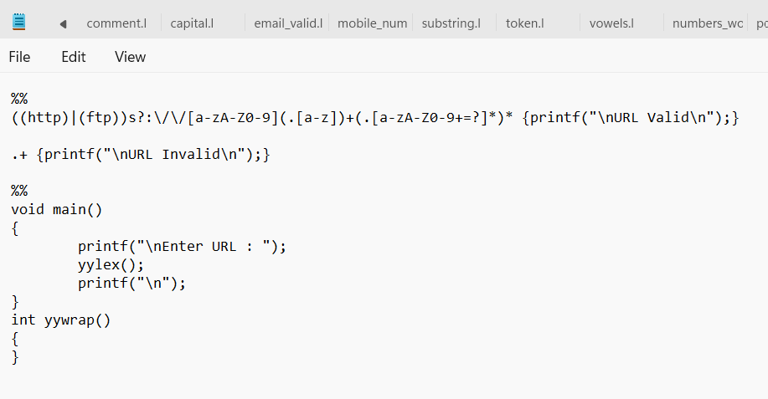
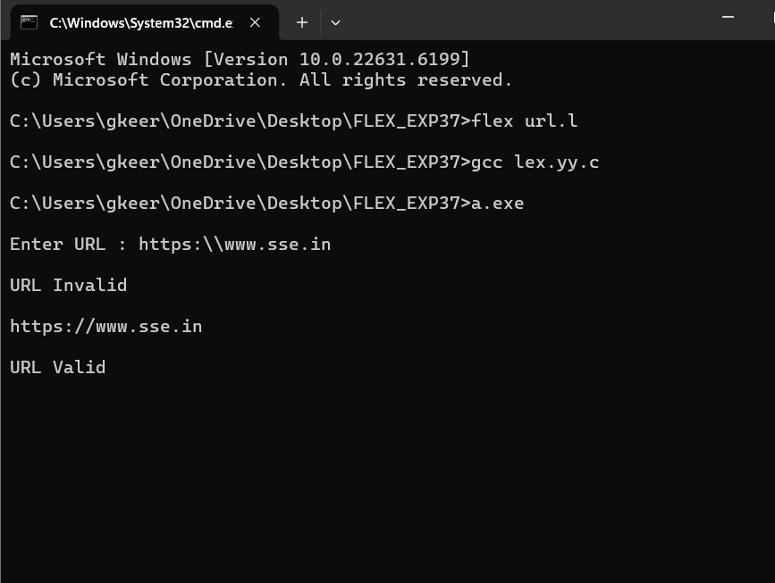

Exp. No. 18
Write a LEX program to validate DOB of students.

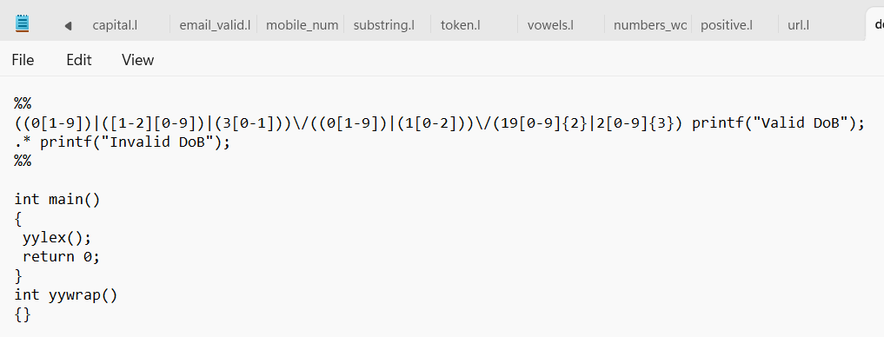

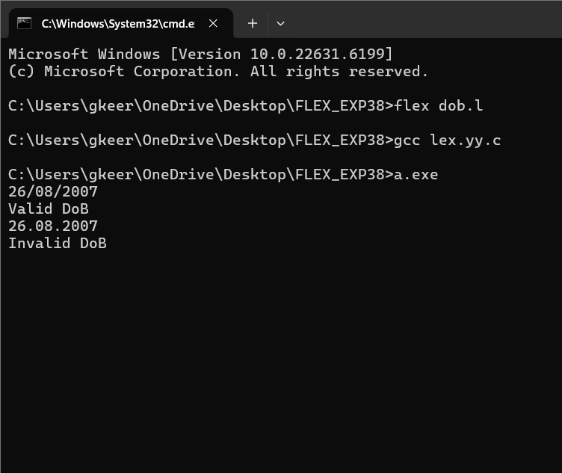

Exp. No. 19
Write a LEX program to check whether the given input is digit or not.

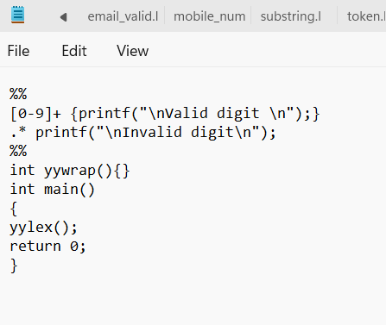
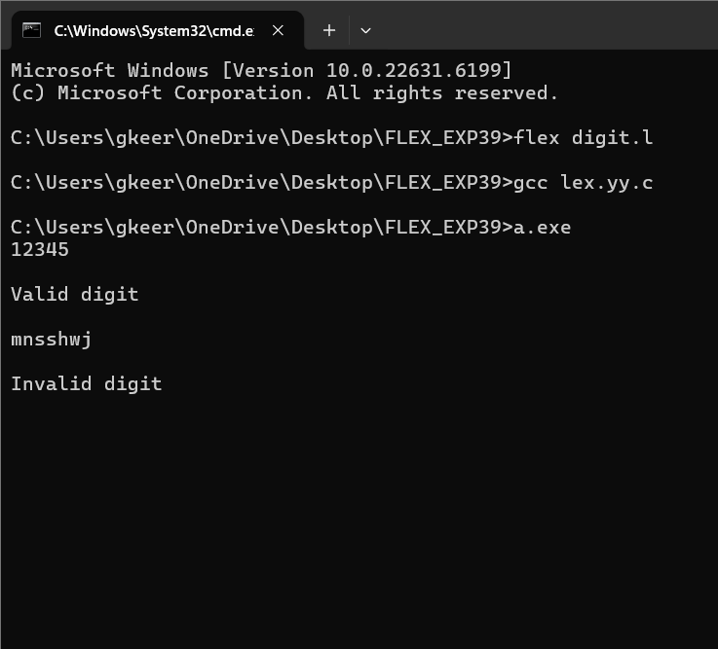

Exp. No. 20
Write a LEX program to implement basic mathematical operations.

